William Frank
3/9/19
Midterm Report

Introduction and Background:
With this project I will be attempting to predict stock price movement, specifically by using news articles and their headlines. Stock prices, and the stock market as a whole, react to events going on around the world, and that reaction is one that can be very hard to predict. Sometimes these events have a more obvious correlation, like a new product being announced, or stock market performance in other countries. Other times however, events are more tenuously related: natural disasters, political happenings, etc. Because my method requires on interpreting headlines it is fundamentally a natural language processing problem.

Motivation:
The stock market is affected by an incomprehensible number of factors in ways that humans could never properly account for. Machine learning algorithms can construct models that take hundreds of thousands of attributes into account when assigning a final label. They can also assign weights to these attributes that might otherwise be completely illogical to a human. The stock market is something that also generates a tremendous amount of data, which needs to be consumed and acted on in a fraction of a second to maximize reward.

Progress:
As the basis of this project is interpreting news articles, my first step was to gather as many as possible. I was able to use a script to scrape information about the most recent 20,000 Reuters articles on various subjects, specifically Business and Economics. The information I was able to scrape was headlines, a short summary, and the date of posting. This gave me news articles dating from February 2nd, 2015 to March 1st, 2019. I paired this with data on the Dow Jones Industrial Average over the same time period. For my first most basic tests I combined all headlines on any given date, and assigned them a label of 1 if the Dow Jones increased or stayed the same that day, and -1 if it decreased that day. To create attributes from the headlines I first used simple token counts, starting with tokens of length 1. This gave me 1025 samples to train and test on, of which I randomly sampled 80% for training and left the rest for testing. The reason for random samples was so that my model might eventually generalize to future news articles better, rather than always training and testing on the same set of events.

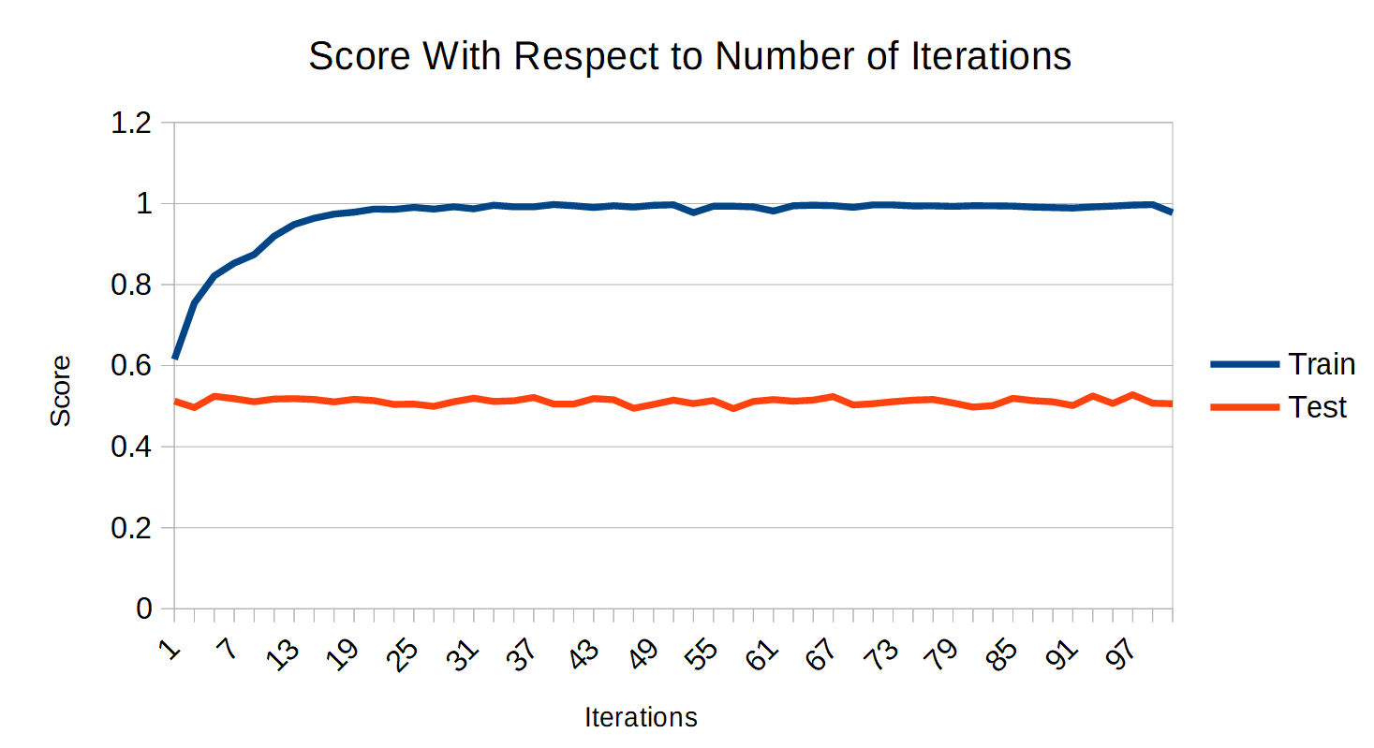
To start with I used Perceptron, as it is a classification algorithm I am familiar with. To get an idea of how well my current attributes map to their labels I measured testing and training error over varying numbers of iterations of Perceptron, reported below. Values are averaged over 20 iterations per Perceptron iteration count.

Even though training error drops to nearly 0 percent, test scores are no better than guessing. Either another model needs to be chosen, or something needs to be done to better prepare the attribute values. To test the first option I trained and tested with several other learning algorithms, as shown in the below chart.

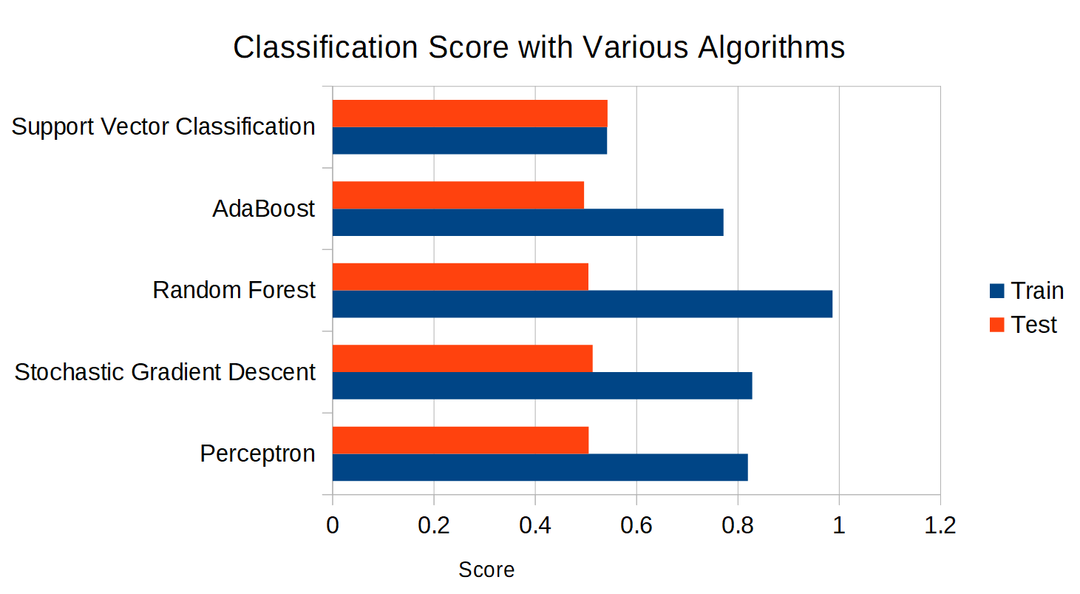
All algorithms are implemented by scikit-learn and ran with default parameters. Obviously something needs to be done to better prepare the attributes. While browsing the documentation for scikit-learn I found tf-idf, a method to transform text into tokens just like the token count vectorizer, however the tokens are weighted in a way that “scale down the impact of tokens that occur very frequently in a given corpus and that are hence empirically less informative than features that occur in a small fraction of the training corpus” [1].

